Using the real-time GUI

Gustav Pettersson January 2018

# Ensure:

You have successfully connected and used all the SPSs on their respective inputs using the manual control GUI. It is imperative that this is done so that everything is connected correctly! **If you have not, go to the “SPS Manual Control GUI” folder and follow those instructions.**

**This guide is only true for the MIST satellite because the simulation data sample in this folder was made for the MIST satellite. This guide is still a useful instruction to understand the purpose and use of the SPS real-time system. We are happy to assist in integrating your simulations for your satellite, just send me an email. Using MIST data on your satellite may destroy it!**

# Software setup:

Since you have successfully used the manual GUI and ensured everything is correct, **copy exactly the setup from “runManual_SPS_GUI” into “runRealtime_SPS_GUI”.** I.e. something like the following:

SPS_HW_IDS = [7 5 6];

SPS_TYPES = {'NO' 'HC' 'HV'};

SPS_LABELS = {'MPPT 1' 'MPPT 2' 'MPPT 3'};

# Hardware setup:

When you have successfully used the manual GUI, do not disconnect the SPSs (to ensure they are not accidentally mixed up) but just close the GUI windows.

# Running:

Run the script. A GUI looking like this should open:

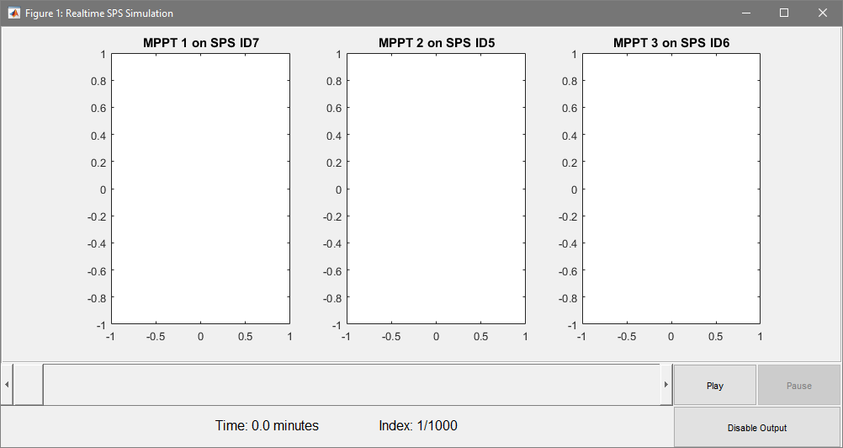

The top part of this GUI shows one plot window for each SPS. What is shown here is always the curve which is programmed into that SPS. If it is blank like here the SPS is disabled. Along the bottom are the controls. There is a timeline which you may move to a desired starting point; the selected time and index in the simulation are shown. The bottom right holds the controls. Pressing “Play” will start the real-time simulation. In the sample simulation, the satellite comes out of eclipse at around 11 minutes, so this is a good starting point. Press “Play” and you should soon see IV curves appearing. At any time, pressing “Pause” will halt the simulation but keep the current output active. It should look like this:

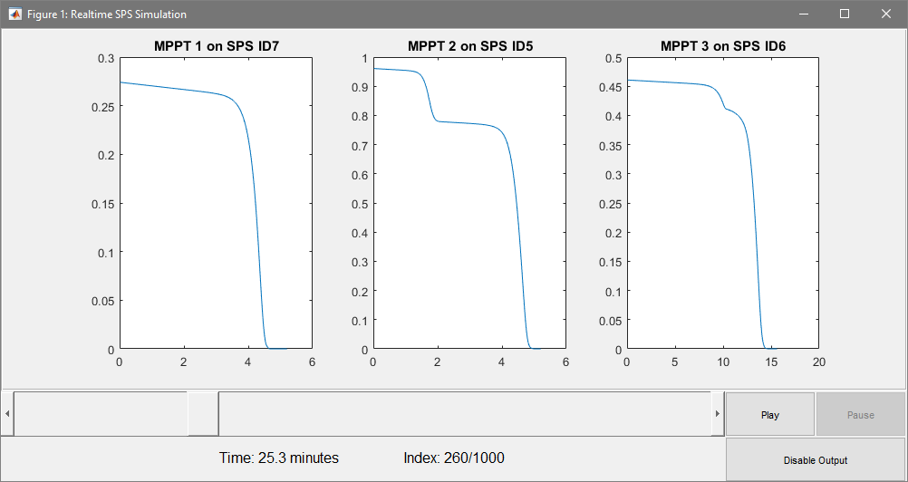

On the other hand, pressing “Disable Output” will disable the output on the SPSs (and halt the simulation). Now press play and enjoy!

# Shutting down

When finished the program will disable the outputs. If you want to finish early, press “Disable Output”. Read the display on the SPS, it should read (almost) 0A of current. Disconnect it from the satellite power system before unplugging the power to the SPS. Close the Matlab window (If you have unplugged the SPS power, you will get an error message in Matlab, this is expected).